**REPORT**

**prepared by: varshini**

**importing libraries:**

import pandas as pd

import matplotlib.pyplot as plt

import seaborn as sns

import numpy as np

**Reading csv file:**

🡪 data=pd.read_csv(r"C:\Users\seeth\python 232\Statistics\cleaned data of autos.csv")

🡪df=data.copy()

🡪df

**1.Can you tell me No of Vehicles by Brand Available on ebay for sale with the help of visualization.**

**Code:**

df["brand"].value_counts()

**output:**

volkswagen 79640

bmw 40274

opel 40136

mercedes_benz 35309

audi 32873

ford 25573

renault 17969

peugeot 11027

fiat 9676

seat 7022

mazda 5695

skoda 5641

smart 5249

citroen 5182

nissan 5037

toyota 4694

sonstige_autos 3982

hyundai 3646

mini 3394

volvo 3327

mitsubishi 3061

honda 2836

kia 2555

alfa_romeo 2345

suzuki 2328

porsche 2215

chevrolet 1845

chrysler 1452

dacia 900

jeep 807

daihatsu 806

subaru 779

land_rover 770

jaguar 621

trabant 591

daewoo 542

saab 530

rover 490

lancia 484

lada 225

Name: brand, dtype: int64

**Code:**

sns.barplot(data=df,x=df["brand"].value_counts().index,y=df["brand"].value_counts())

plt.xticks(rotation=90)

plt.title("No. of vehicles based on brands")

plt.xlabel("brands")

plt.ylabel("No.of vehicles")

plt.show()

**Output:**

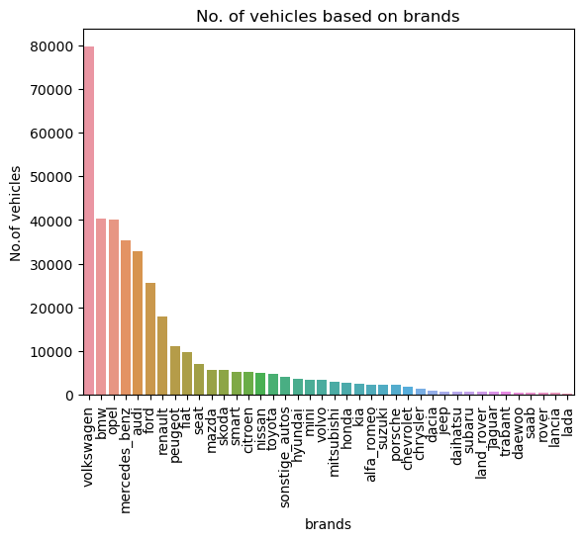

**Explanation:** From the above graph, there are more (79640) number of Volkswagen vehicles and less(225) number of lada vehicles available in the ebay.

**2.What is the Average price for vehicles based on the type of vehicle as well as on the type of gearbox. Explain me with both numerical and visualization analysis.**

**Code:**

sns.barplot(data=avg_price_of_vehicle,x="vehicle_type",y="price")

plt.xlabel("average price")

plt.ylabel("vehicle type")

plt.xticks(rotation=90)

plt.show()

**Output:**

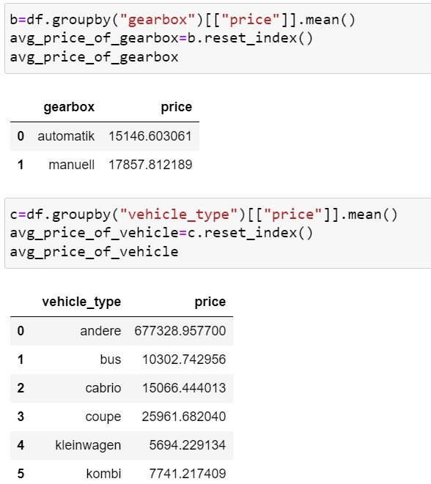

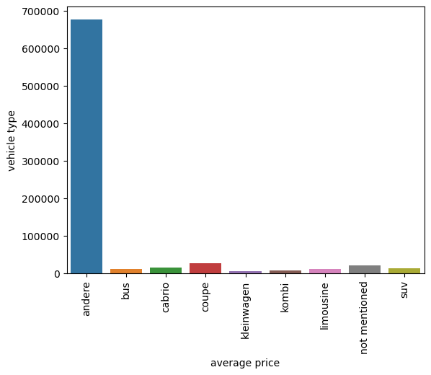

**Explanation:** In the above barplot the average price of andere vehicle is high compared to

other vehicle.

**Code:** plt.pie(avg_price_of_gearbox.price,labels=avg_price_of_gearbox.gearbox,autopct='%1.2f%%')

plt.show()

**Output:**

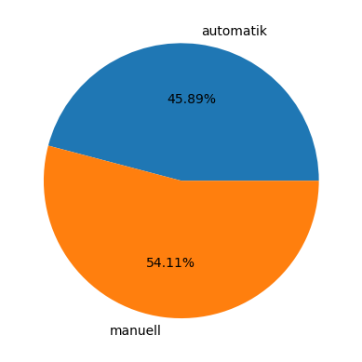

**Explanation:** The average price of gearbox-automatic is 45.89% and gearbox-manuell is 54.11%.

**3. What is the marginal probability of private seller.**

**Code & Output:**

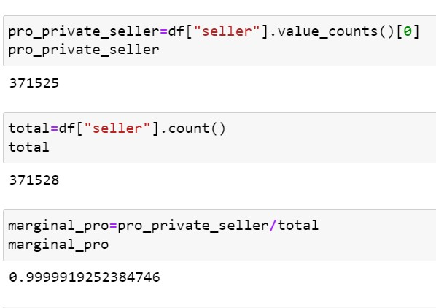

**Explanation:** The above output is the marginal probability of private seller which is 0.9999.

marginal probability=probability of private seller/Total.